**APPENDIX 1**

***HOSTEL ACCOMODATION SYSTEM FOR THE STUDENTS OF LPU***

END TERM REPORT

***by***

Myla Saahas Maneesh Kumar

(Section: K19XC) (Section: K19XC)

(Roll Number: 10) (Roll Number: 11)

Mandala Benarji Adithya s

(Section:K19XC) (Section: K19XC)

(Roll Number:12) (Roll Number: 09)



**Department of Intelligent Systems**

**School of Computer Science Engineering**

**Lovely Professional University, Jalandhar**

April-2020

**APPENDIX 2**

## Student Declaration

This is to declare that this report has been written by me/us. No part of the report is copied from other sources. All information included from other sources have been duly acknowledged. I/We aver that if any part of the report is found to be copied, I/we are shall take full responsibility for it.

Myla Saahas

(Roll Number: 10)

. Maneesh kumar

(Roll Number: 11)

Aadithya s

(Roll Number:09)

Mandala Benarji

(Roll Number:12 )

### Place:

### Date

#### APPENDIX 3

#### TABLE OF CONTENTS

**TITLE PAGE**

1. **Background and objectives of project assigned ................** **1**
   1. ........................................................................................ 1
      1. **....................................................................................** **3**
      2. **.....................................................................................** **5**
   2. **.........................................................................................** 7
      1. **.....................................................................................** **7**
      2. **.....................................................................................** **9**
      3. **.....................................................................................** **10**
2. **Description of Project ... ........................................................** **14**
   1. **..........................................................................................** **17**
   2. **..........................................................................................** **18**

APPENDIX 4

BONAFIDE CERTIFICATE

Certified that this project report “………. BLOOD DONATION.......” is the bonafide work of “…………..Myla Saahas, Maneesh Kumar, Aadithya s and Mandala Benarji…………” who carried out the project work under my supervision.

<<Signature of the Supervisor>>

<<Name of supervisor>>

<<Academic Designation>>

<<ID of Supervisor>>

<<Department of Supervisor>>

**1.Background and objectives of project assigned**

* Online registration of hostel for LPU students.
* There is availability of login for students who already
* have accounts and sign up for register account as a
* new user.
* Availability of rooms can be checked.
* There is also an option for hostel preference.
* We can select a room from 1 seater to 6 seater.
* There is also an option to select mess and laundry
* services.
* There is a help centre for students which shows
* detailed procedure to book a hostel room.
* If the user faces any problem they can report a
* problem.
* Students can also request to deallocate laundry or
* mess services.
* Feedback can also be given.
* The main requirement of this project is to make
* hostel booking online and easy to access for the
* students of LPU.
* Any education institution can make use of providing
* the same service.
* It can be used easily modifications can be easily done
* according to requirements.
* The application is used to convert the manual
* application to the web application.
* User does not have right to enter information about
* hostels.
* It’s a well organised software solution for a University.
* hostels to user. It keeps a track of booked rooms and

**2.Description of project.**

**LPU LOGIN PAGE:**

* Users can login using their respective registration numbers and passwords.
* Used table form ,image, href and background image.

**INDEX PAGE:**

* Users can read the information given by university about hostel life.
* Used image tags, inline css, css and animation for automated image slideshow.
* Used <h1><h2>……<h6> and <p> tags including href and img src.

**HOSTEL BOOKING PAGE:**

* User can define required kind of rooms using given features.
* Used radio, phone , select and option tags including href and other essentials.

**HOSTEL INFO PAGE:**

* Table and form is used in this page to show the fee patterns.
* Various facilities provided are explained in tabular form.

**FINAL PAGE:**

* Here you can submit feedback.
* You can also report any problem.
* Css is used to design.
* Background images and other essential tags are used.

**3.Description of Work Division in terms of Roles among Students.**

**Aaditya**

Creating button for log in and sign up.

collecting the various suitable tags to the given project.

Creating the columns for information about hostel

accommodation procedure in LPU.

And creating link to the page with external css and

like font styles and background of document.

**Saahas**

To design the whole page with coding html and

adding internal and inline css.

Creating the help center which explains the

procedure of hostel booking.

Creating feedback structure through which feedback

can be given.

Also making the synopsis for the project.

**Maneesh**

Creating the service support such as allocation of

laundry and mess.

Creating the deallocation of already availed services

of laundry or mess or both.

And adding additional design to the project.

Providing information to user about all the hostel

types and services.

**Benarji**

Creating the report a problem interface.

Creating the additional options like room and hostel

preferences.

Providing images for this project.

And adding some more information about required

tags for the project.

**4.Implementation of scheduled work of project**.

* Screenshots of the website:

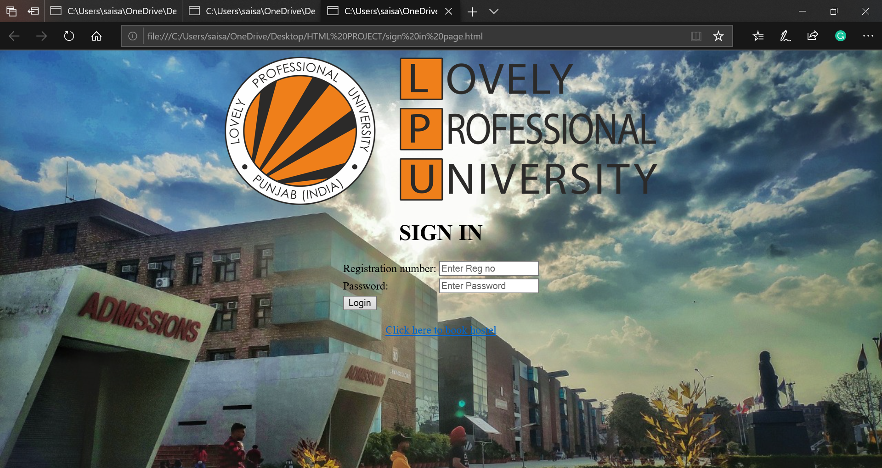

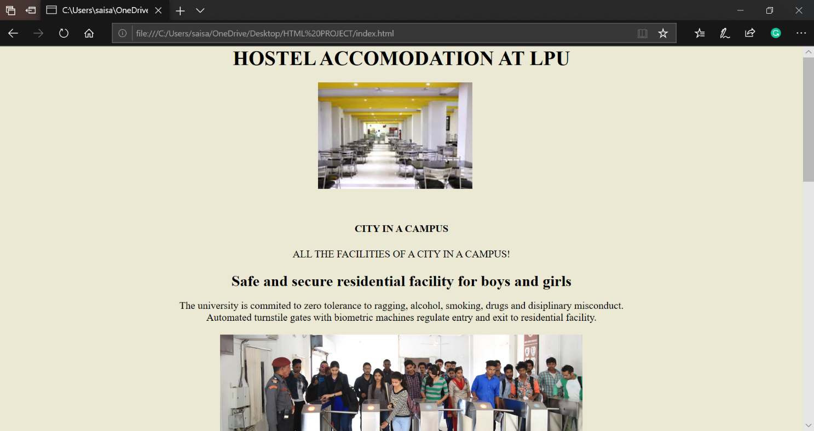

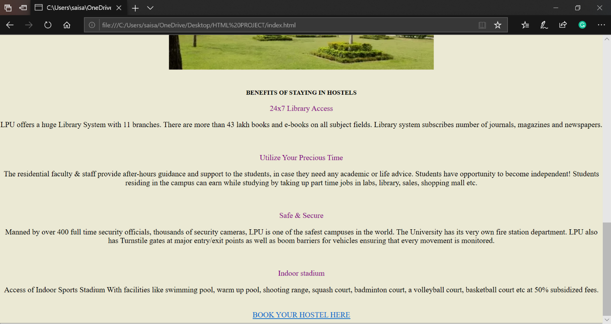

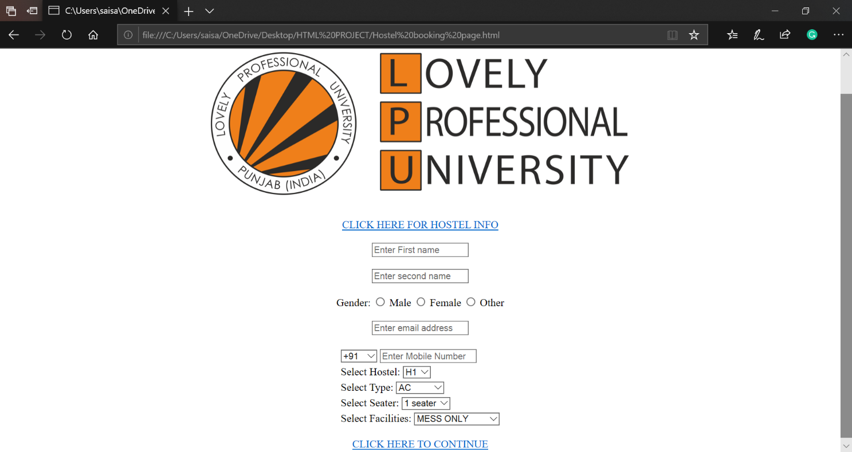

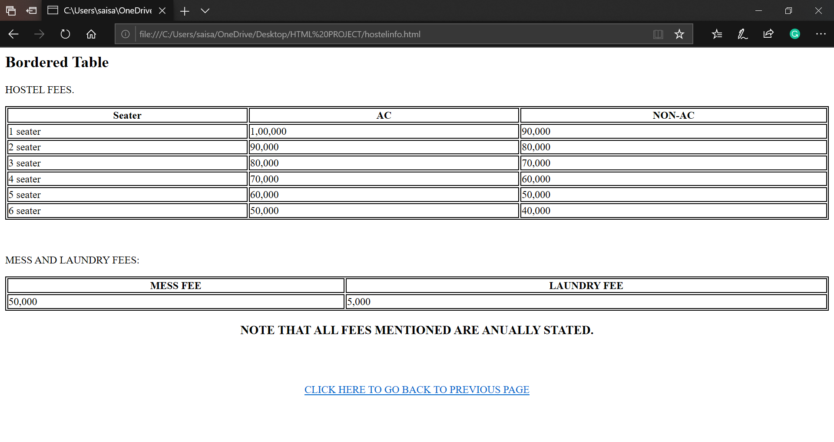

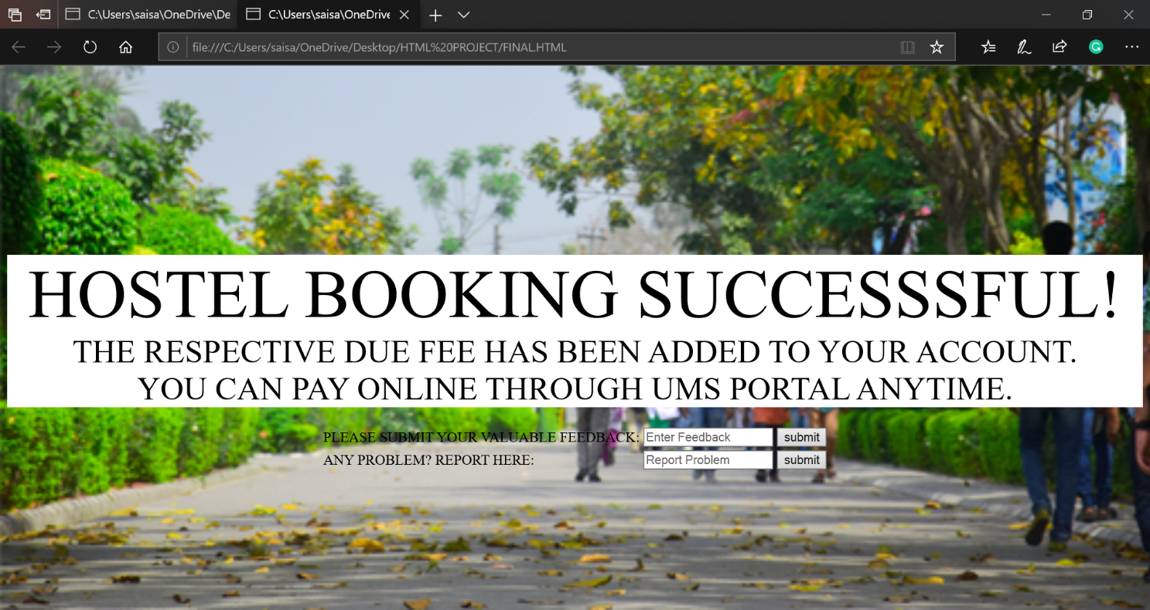

***GANTT CHART:***

